

**Fluree + Postman Guide:**

Note: Before starting, ensure you have a Fluree server up and running. You will need the URL from the local host server the Fluree image created. The default is <http://localhost:58090>. You can create a Fluree Server by using the Docker image for Fluree Server. You can find the latest pull command for Fluree server [here](https://hub.docker.com/r/fluree/server). In Postman you can either start from scratch and create your own Collection or alternatively use the Fluree Cookbook example and adjust the data:

[cookbook](https://next.developers.flur.ee/docs/reference/cookbook/)

* Click the orange ”Run in Postman” button to create a fork of the Cookbook example.

**Creating a Request:**

1. After creating a collection and necessary folders to neatly store your requests, right click on the folder name and click **add request**:
2. In the following screenshot please observe the numbered sections. 1 – Should be Post, 2 – should be raw and 3 – should be JSON (Easiest)

* Also note the URL next to “Post”, fluree/transact indicates a transaction.
  + If you wish to create a new ledger the URL should end with /fluree/create.
  + If you wish to query an existing ledger the URL should end with /fluree/query

1. In the body section you can now type the request in a JSON-LD format. For example:

{

    "@context": {

        "aia": "http://purl.org/aiaontology#"

    },

    "ledger": "aiao/base",

    "insert": [

        {

            "@id": "bob", *//not linked data (No prefix for an IRI)*

            "@type": "aia:Operator",

            "aia:Operates": {"@id":"piano"}

        },

        {

            "@id": "yamaha_0_0_1", *//this is not a linked data example*

            "@type": "aia:Instrument",

            "aia:hasRegistry":"1.0",

            "aia:hasMake":"Yamaha",

            "aia:wasManufacturedOn": "2020-05-15",

            "aia:hasDescription": "This is a yamaha piano",

            "aia:isOperatedBy": {"@id": "bob"}

        }

    ]

}

1. Simply click the send button next to the URL.

**Creating a Fluree Ledger:**

1. To create a fluree ledger you must start by creating a **request** as mentioned above.
2. Ensure that the URL in your request is the same one your Fluree Server is using, usually: <http://localhost:58090>.

The URL should look like the following: [**http://localhost:58090/fluree/create**](http://localhost:58090/fluree/create) .

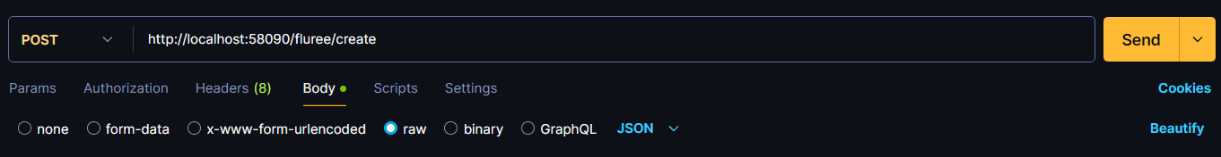

1. Now you can type the **body** of the request in JSON format (**View my Fluree Data Guide pdf)**.

**How to export curl or other formats from Postman:**

1. 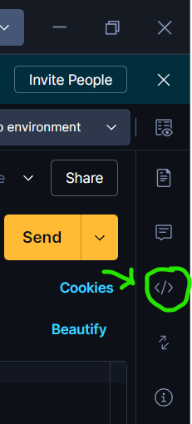While you are inside the Request you wish to convert, on the right-hand side of the screen is a “</>” symbol:
2. A new window will open and, in the top,-left of this new window will be a drop-down list, with various formats the Request can be converted to, for example Curl, R, Python etc.

